**NETWORKING & SYSTEM ADMINISTRATION LAB**

**Name: Jesnamol Thomas**

**Roll No: 6**

**Batch: B**

**Date: 04/04/2022**

**Experiment No.: 2**

**Aim**

Identify the major components of a computer systems such as Motherboard, RAM modules, Daughter cards, Bus slots, SMPS, Internal storage devices and Interfacing ports.

**Procedure**

Motherboard

A motherboard is the main printed circuit board (PCB) in general-purpose computers and other expandable systems. It holds and allows communication between many of the crucial electronic components of a system, such as the central processing unit (CPU) and memory, and provides connectors for other peripherals. Unlike a backplane, a motherboard usually contains significant sub-systems, such as the central processor, the chipset's input/output and memory controllers, interface connectors, and other components integrated for general use. Motherboard Components are Mouse & keyboard, USB, Parallel port, CPU Chip, RAM slots, Floppy controller, IDE controller, PCI slot, ISA slot, CMOS Battery, AGP slot, CPU slot, Power supply plug in

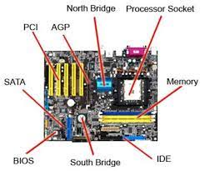

RAM modules

RAM (random-access memory) is a printed circuit board on which memory integrated circuits are mounted. RAM permit easy installation and replacement in electronic systems, especially computers such as personal computers, workstations, and servers.The first memory modules were proprietary designs that were specific to a model of computer from a specific manufacturer.Later, memory modules were standardized by organizations such as JEDEC and could be used in any system designed to use them.

Types of memory module include: Trans Flash Memory Module, SIMM-a single in-line memory module, DIMM-dual in-line memory module.

Distinguishing characteristics of computer memory modules include voltage, capacity, speed (i.e., bit rate), and form factor. For economic reasons, the large (main) memories found in personal computers, workstations,and non-handheld game-consoles (such as PlayStation and Xbox) normally consist of dynamic RAM (DRAM).Other parts of the computer, such as cache memories normally use static RAM (SRAM). Small amounts of SRAM are sometimes used in the same package as DRAM. However, since SRAM has high leakage power and low density, die-stacked DRAM has recently been used for designing multi-megabyte sized processor caches.

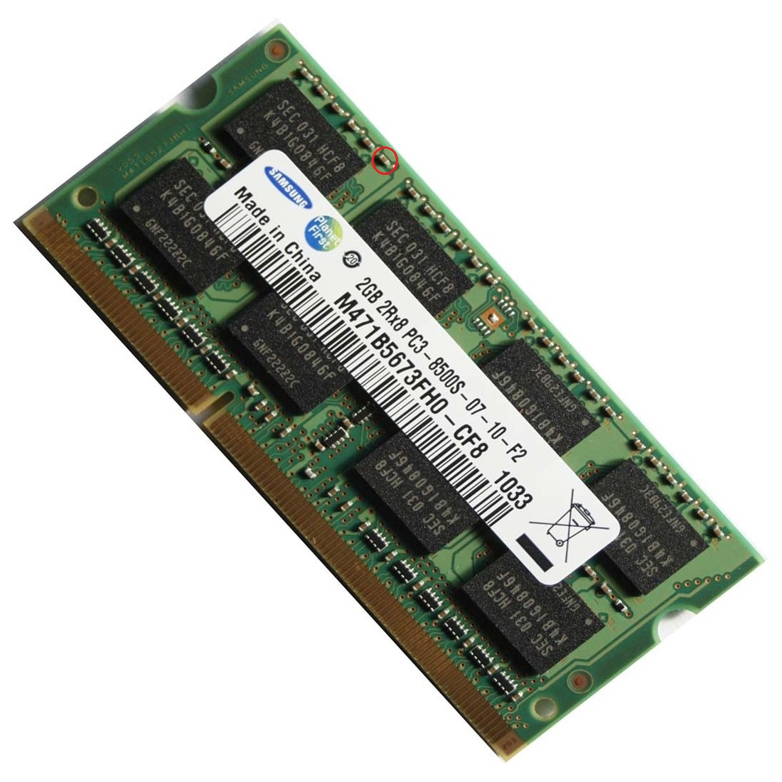

Daughter cards

A daughter card or daughterboard is a type of circuit board that gets added to an existing one. A daughter card is type of circuit board that plugs in or is attached to the motherboard or similar expansion card to extend its features and services. A daughter card complements the existing functionality of a motherboard or an expansion card. A daughter card is also known as piggyback board, riser card or mezzanine board. Unlike expansion cards, which connect with the motherboard using bus and other serial interfaces, daughter boards are usually directly embedded through soldering.

Like a motherboard, a daughterboard has sockets, pins, plugs and connectors to be attached to other boards. Typically, daughter boards are released as a post-launch update to a motherboard or expansion card. For example, a MIDI daughterboard is used to add on the functionality of the sound card.

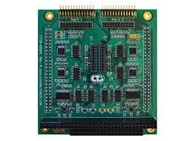

BUS slots

A Bus slot or expansion port, an expansion slot is a connection or port inside a computer on the motherboard or riser card. It provides an installation point for a hardware expansion card to be connected.

An expansion slot is a socket on the motherboard that is used to insert an expansion card (or circuit board), which provides additional features to a computer such as video, sound, advanced graphics, Ethernet or memory.

The expansion card has an edge connector that fits precisely into the expansion slot as well as a row of contacts that is designed to establish an electrical connection between the motherboard and the electronics on the card, which are mostly integrated circuits. Depending on the form factor of the case and motherboard, a computer system generally can have anywhere from one to seven expansion slots. With a backplane system, up to 19 expansion cards can be installed.

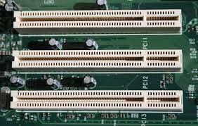

SMPS

A switched-mode power supply (SMPS) is an electronic power supply that incorporates a switching regulator to convert electrical power efficiently. Like other power supplies, an SMPS transfers power from a DC or AC source to DC loads, such as a personal computer, while converting voltage and current characteristics. Unlike a linear power supply, the pass transistor of a switching-mode supply continually switches between low-dissipation, full-on and full-off states, and spends very little time in the high dissipation transitions, which minimizes wasted energy. A hypothetical ideal switched-mode power supply dissipates no power.

Voltage regulation is achieved by varying the ratio of on-to-off time (also known as duty cycles). In contrast, a linear power supply regulates the output voltage by continually dissipating power in the pass transistor. This higher power conversion efficiency is an important advantage of a switched-mode power supply. Switched-mode power supplies can also be substantially smaller and lighter than a linear supply because the transformer can be much smaller. This is because it operates on the switching frequency which ranges from several hundred kHz to several MHz in contrast to the 50-60Hz which is typical for the mains AC frequency. Despite the reduction in size, the power supply topology itself and the requirement for electromagnetic interference (EMI) suppression in commercial designs result in a usually much greater component count and corresponding circuit complexity. change the voltage to the appropriate range for the computer

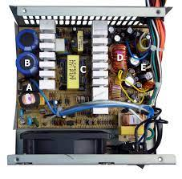

Internal storage devices

Internal storage allows the data and applications to be loaded very rapidly into memory, ready for use. The data can be accessed much faster than data which is stored on an external storage device. This is because internal storage devices are connected directly to the motherboard and its data bus whereas external devices are connected through a hardware interface such as USB, which means they are considerably slower to access.

Internal storage also means that if the computer is moved around, it will still retain its most commonly used data. The main disadvantage of internal storage is that when the hard disk fails (and it will), all the data and applications may be lost. This can be avoided to some extent by using more than one hard disk within the machine. Each hard disk has a copy of all the data, so if one fails the other can carry on. This is called a RAID array. An alternative is to use external drives for backup

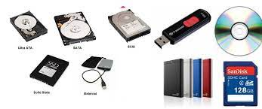

Interfacing ports

A Computer Port is an interface or a point of connection between the computer and its peripheral devices. Some of the common peripherals are mouse, keyboard, monitor or display unit, printer, speaker, flash drive etc. The main function of a computer port is to act as a point of attachment, where the cable from the peripheral can be plugged in and allows data to flow from and to the device. A computer port is also called as a Communication Port as it is responsible for communication between the computer and its peripheral device. Generally, the female end of the connector is referred to as a port and it usually sits on the motherboard.

In Computers, communication ports can be divided into two types based on the type or protocol used for communication. They are Serial Ports and Parallel Ports. A serial port is an interface through which peripherals can be connected using a serial protocol which involves the transmission of data one bit at a time over a single communication line. The most common type of serial port is a D-Subminiature or a D-sub connector that carry RS-232 signals. A parallel port, on the other hand, is an interface through which the communication between a computer and its peripheral device is in a parallel manner i.e. data is transferred in or out in parallel using more than one communication line or wire. Printer port is an example of parallel port.

